


Dec/2008

Understanding and Acting within Loweswater: a
Community Approach to Catchment Management

This leaflet… contains a brief summary of our findings from the research we have been doing for the project ‘Understanding and Acting In Loweswater’. The research began in June 2007 and continues until December 2010.

We feel privileged to work with the people of Loweswater on issues relating to their local environment. Our project encompasses:

- ecological surveys of the land and consultations with farmers on a range of farming strategies and land-use options;
- scientific monitoring of the lake;
- institutional analysis of regulatory bodies that play a role in Loweswater;
- in-depth interviews with local residents; and
- the setting up of the Loweswater Care Project (LCP), a group of stakeholders (local, institutional, and others) that explore issues and actions linked to the sustainability of Loweswater.

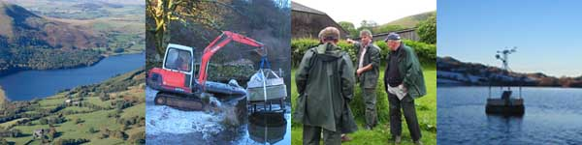

We present this research update in three sections:

- Social Science Summary, pp. 2-7
- The Loweswater Care Project, p. 7
- Science Summary, pp. 7-11

- SOCIAL SCIENCE SUMMARY

Researchers working on this part of the project are Judith Tsouvalis, Claire Waterton, Nigel Watson (Lancaster University), Ken Bell (Community Researcher, Loweswater).

Local Knowledge Counts

On the social science side of this project, in-depth interviewing of local residents began in March 2008. In the catchment, we have so far spoken to 20 people (including 4 interviews with couples) from 13 households, 3 of which were farms. In these interviews, the following themes were explored:
- the community of Loweswater;
- land-use change in the catchment;
- Loweswater lake;
- the management and ‘maintenance’ of the land and the lake;
- septic tanks and household detergents;
- science and our project;
- relations with regulatory bodies impacting on Loweswater.

All interviews are transcribed, and in our analysis we look for patterns, issues and recurrent themes. Below, some preliminary findings from these interviews are introduced.

‘The Community’ of Loweswater

Our research is called ‘A Community Approach to Catchment Management’. Since March 2008, we have been interviewing local residents and trying to get a sense of what it means to be part of the community in Loweswater.

Views of Loweswater as a community vary. Interviewees often observed that people help and support each-other in times of need. For some, this provides a sense of community, while for others, shared activities such as walking (the Mockerkin Mob), participating in local clubs (Loweswater 77 Club, The Gardening Club, the Lorton Tennis Club) and societies (the Local History Society), or taking part in local events (Farmers Discussion Group; Loweswater Show) is of more significance in terms of feeling a sense of belonging. Older local residents, who constitute a large proportion of the people living in the catchment, often recall what village life was like in the past. These memories influence their perceptions of the community of Loweswater as it is now. For example, a common perception is that there were more farmers and children in the catchment in the past, and not so many incomers; that church-life had been more active, and that “at one stage”, the local drama group “was everybody’s life”! These kinds of memories often highlight the demographic and societal changes typical of many Lake District communities.

At another level, the idea of ‘community’ and ‘belonging’ is quite complex. Many of our interviewees classed themselves as ‘offcomers’ (residents not born in Loweswater), which, by definition, puts true locals (those born in Loweswater) in a minority in the valley. And yet being an ‘offcomer’ does not mean being an ‘outsider’. Most ‘offcomers’ feel well integrated in Loweswater.

The ‘offcomer/local’ dynamic is played out in positive and practical ways on the ground. For example, ‘offcomers’ are often asked to carry out specific tasks and fulfil certain roles in the many small societies and local organisations that exist (eg. church warden, specific organisational roles, involvement in lent lunch- or harvest supper preparations). In fact, many of the societies and clubs existing in Loweswater were founded by ‘offcomers’, serving the interests and enthusiasms of locals and offcomers alike. Locals bring additional strength to the idea of ‘community’: above all, they are respected and relied upon for their knowledge and experience of Loweswater.

In some interviews the community is described as being divided by the geography of Loweswater: some would say that there are two communities in Loweswater – one at Waterend and the other at Watergate (‘There’s a lake between this end of the valley and the other end!’). Despite these distinctions (local/offcomer, northwest/southeast end of the lake), there was a general sense that the community in Loweswater is ‘close-knit’, ‘well-integrated’, and generally very friendly. Whilst most people participate in local life, there are some who choose not to mingle and whose interests lie elsewhere.

Memories, experiences and local knowledge are important for our project which aims to help build a bottom-up, community based, organisation – the Loweswater Care Project (LCP). LCP participants are working together to create and maintain a sustainable environment in this valley. In order to succeed, we all need to think about how the community works, and how the community could work effectively for the LCP.

Agricultural- and land-use change in the catchment

There is a total of 273ha of in-bye land (grassland), 130ha of woodland, and 371ha of fell in the catchment area. The most significant changes in land-use in Loweswater in the last 50+ years have come through farming. Again, the memories of older Loweswater residents are an important source of knowledge for gaining a better understanding of land-use change over time:

- Farms in the past were run on a rotation system and grew most, if not all, of their own feedstuffs
- The composition of animals in the catchment was more diverse in order to sustain multiple needs: there were cows (milk and beef), draught horses, poultry (eggs), sheep (for wool – an important source of income at one time - and meat), and pigs, sheep and hunting dogs
- There were more farms, farmers, and hired farm-hands, and the whole family often worked on the farm
- There was haymaking instead of silage making (a change introduced in the late 1970s/early 1980s)
- Farmers helped each-other clip the sheep manually, a social activity that declined when electrical shears came in
- Farmers had less land out of the catchment

Farmers have been encouraged to change their day to day farming practices in the last few decades for many reasons. Drivers of change have been scientific and

technological advances, as well as government subsidies supporting the production of as much food as possible after WWII. Other changes followed, with environmental schemes trying to alleviate problems induced by earlier shifts towards intensified agricultural production. These changes are well illustrated by the following quotation:

“When my father farmed here, he [...] had a crop rotation, he [...] milked twelve cows and there would be one or two young calves... [...]. And he definitely, definitely, didn’t have any other land… Now in the last twenty years, because of the headage system…… the subsidies really were good money. So … the more [livestock] you kept, the more [money] you got. And people, nearly everybody, even we joined in, would have land away from these holdings. So although we lived and farmed here we all had land away and all that stock came home at winter. [...] At one stage we would have, [...] here on concrete, was it seventy or eighty [cattle]?”

Another interviewee observed that when fertiliser was introduced,

“It was a revolution ... because ... people didn’t have to keep ploughing it [the land] and reseeding it. I mean, there isn’t the labour to do it now, is there?.....To my way of thinking a lot of it isn’t farmed anymore, it’s just ranched really isn’t it? It’s just grazed. You put fertiliser on and put the stock on and just graze it”.

Farmers themselves are acutely aware of the rapid changes that have occurred in their own lifetimes and also aware that not all of them have been for the better. To one respondent it was clear that:

“Farmers [in the past] more or less knew what they were doing and they did it, but nowadays it is all just so controlled and you aren’t allowed to do this and you’ve got to have a license for that and you’ve got to ask for permission for the other. Farming is a nightmare, I’ll tell you”.

For most farmers, farming is their livelihood and a way of life. Loweswater farmers have been very proactive to date in addressing some of the problems associated with modern farming practices. This is a great asset if the community is to work together as a whole on exploring the future sustainability of Loweswater. Our interviews with farmers continue to investigate their own experiences of change as well as looking into possibilities for viable and sustainable farming futures for the catchment.

Loweswater Lake

All our respondents were aware of the algal blooms on Loweswater, but the degree to which they worried about them varied. ‘Will nature not find a new balance?’, one interviewee asked, while another lamented that the lake is taken for granted by the community: ‘You are aware of it and you sort of ‘tut, tut’ and you stand at the top of Low Fell and see that the bloom is bad today’. However, many people were very concerned that ‘the lake might die’. Some felt that the lake was pivotal to the community of Loweswater: ‘If we have a dead lake, then we’ve got a dead community’. It is worth noting that for those for whom the lake has a use-value (be it in
the form of swimming fishing, walking dogs, or attracting tourists who bring revenue to the area), concerns about algal blooms were more acute.

Past memories here provided valuable pointers for the reconstruction of environmental change. For example, one residents’ father had felt that when water was diverted from a stream flowing into Loweswater at Holme. Force, that ‘Someday that lake will become stagnant’, and two respondents believe that the waterfall known as the Mare’s Tail carries less water than it did in the past: ‘[that] waterfall ...always seemed a hell of a lot bigger…’. Recollections of using the lake also led to comments on climate change:

“when it was wintertime, when it was frozen, we used to break the ice on the lake for the animals to drink. […] It used to freeze over, yes. .. They used to play football on it and they’d ride on it with their motorbikes. Not every year… but some years”.

One interviewee thought that, in the past, they:

“definitely had drier summers… we used to have six weeks holiday and … we kind of lived in our bathing costumes. […] You’d have to have better weather to bring the hay in… it was a slow process. […] That lane into Watergate used to be so dusty… […] We used to go into our summer frocks and sandals at Easter, every year, so it was definitely warmer in the Spring; definitely warmer in the Spring!”.

As part of our project we are carrying out scientific monitoring of the lake. We are doing research on regulations and institutions that have connections and responsibilities for the lake and lake water. We are also committed to working with residents in Loweswater to help think through what can be done to best utilize local knowledge and local care for the lake. Many people are aware of the complex ecology of the lake and want to know more about it. This curiosity coupled with local knowledge and experience, scientific research, and monitoring provides a powerful combination for thinking through the question of ‘what to do’.

Management and Maintenance of Land and the Lake in Loweswater

A recurrent theme in our interviews concerned the ‘maintenance’ of Loweswater’s natural environment. What in the past seems to have been actively and routinely managed and maintained, mostly through local labour, is, in the views of many local people, no longer properly done: “I don’t think it’s kept like it used to be.” This general category of ‘management and maintenance’ includes comments on:

- woodland management;
- the dredging of sediments from Dub beck to increase the water-flow (especially at the Watergate end);
- fish stock management; and
- the management and clearing of vegetation and trees alongside the lakeside.

People reflected on how environmental institutions (or ‘The Agencies’) had changed their views of land drainage and dredging. Land drainage, it was observed, is now seen as ‘flood risk management’; dredging as a risk to species and habitats. These changes in perception have practical knock-on effects, which has led Loweswater residents to

ask if present (non-) management strategies are appropriate for this environment and whether they might not actually contribute to the deterioration of lake water quality.

Observations made by residents of changes in management could mean we need to look into the effects of different management regimes to complement research already underway.

Septic tanks and household detergents

Most residents are aware that household- and human waste might have an impact on the lake: “I mean the houses. I mean there is run-off, and chemicals, people now have dishwashers and so-on and so-forth. They could contribute, I wouldn’t know.” All interviewees to date have septic tank systems for their domestic waste waters. People generally have a good knowledge of their own septic tanks and know when they were last cleaned out. CEH have done some work on septic tanks in response to the survey carried out by the Environment Agency in 2000 and will be taking their impact on the natural environment into account in the modelling phase of their work (see p12).

Septic tanks and the use of domestic chemicals in washing powders and cleaning products might be explored in a future LCP meeting.

Science and Views of Our Project

Most of the people interviewed welcomed the attention being paid to the lake by CEH and Lancaster University researchers and many thought that involving the community in the project was invaluable if anything was to be achieved. One respondent recalled how the National Rivers Authority had come to take samples of the lake water in the past, but had never come back with any results; unfortunately this kind of practice has caused some resentment. Other issues that people have mentioned they would like to see researched include:

- the role played by sceptic tanks and detergents in lake water quality reduction;
- the reasons for the slow turnover of the water in the lake (particularly the role of dredging/not dredging);
- the role of leaf litter (from trees around the edge of the lake) on nutrient levels in the lake and the effect of woodland planting on land and water;
- the connection between fish-stock decline and algal growth;
- pollution related to cars and tourism;
- post-war farming and other historical changes that might have contributed to today’s problems.

It is worth noting that several local residents have engaged in what might be referred to as lay-science. Some have carried out regular monitoring of rainfall and taken note of weather patterns. One resident has been involved in research on wildfowl; another has done a school project on local perceptions of the algae; and another has measured radioactivity-levels in the lake and surrounding area after the Chernobyl incident. At

present we are aware of two trained retired chemists in the catchment, a local historian, and three retired medical doctors.

Given the expertise and the interest in the catchment, the LCP could think of ways in which local monitoring could be set up to gather useful on-site data.

Relations with Regulatory bodies impacting on Loweswater

Research in this area is still in its early stages, but one finding that we have made in our interviews with local residents so far is that relations between the National Trust, other regulatory bodies, scientists, and local residents are sometimes strained. Local people feel that their views can be disregarded at public meetings:

“I raised this [impact of human waste from walkers on water quality] at a Parish Council meeting [...] but it was a bit dismissed. [...] I think it’s something that should not be just totally dismissed because there has been really an enormous increase in the number of people walking around the lake.”

“I once went to a meeting at the Village Hall because I was a bit obsessed about all these branches in the lake you know, which I said ... that it wasn’t very good. And the NT pooh-poohed it and said it wasn’t relevant, you know.”

Several interviewees thought that it was important that the agencies began to listen and actually ‘do their bit’. One interviewee stressed that there needed to be more action, and that the institutional stakeholders (Environment Agency, National Trust, National Parks Authority, and Natural England) needed to work with the community to ‘see what the community wants’.

This project aims to help bring about better relations between local- and institutional stakeholders so that positive action and results that have relevance to all parties can be achieved by working together.

- The Loweswater Care Project (LCP)

A community and an institutional stakeholder meeting were held at the beginning of the project in November 2007. From then on we have held community and institutional stakeholder meetings together, in the form of the LCP.

1st LCP meeting

The 1st LCP meeting ‘proper’ took place on the 18th of June 2008. The meeting attracted nearly 30 participants and generated lively discussions. Participants also changed the name of the group by vote, from ‘Loweswater Knowledge Collective’ (as it was initially called by Lancaster researchers) to the ‘Loweswater Care Project’.

The meeting was held as a workshop where participants shared knowledge and memories
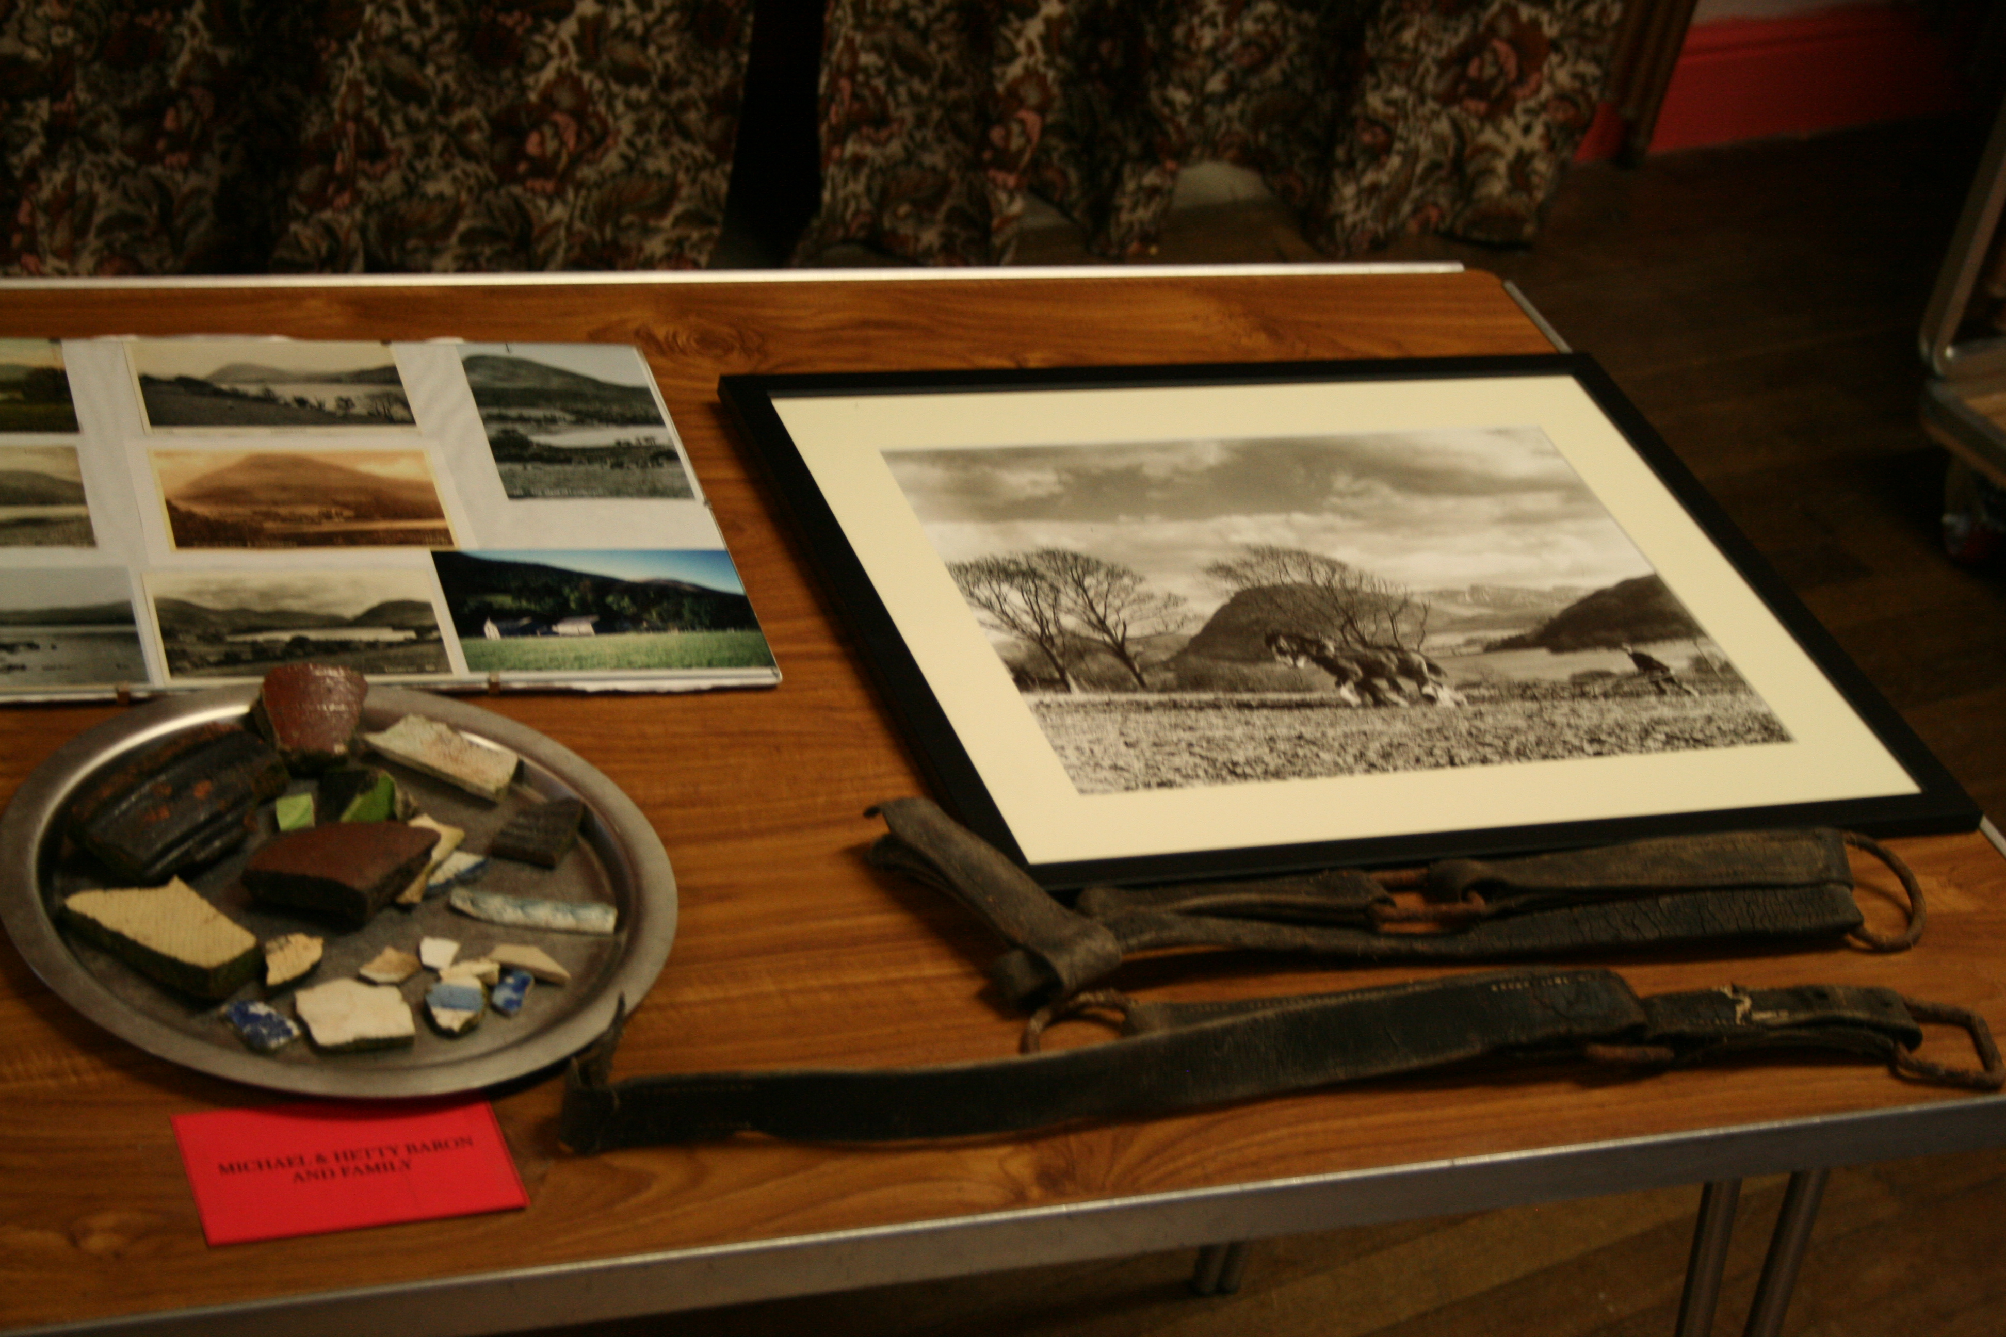
of Loweswater through objects, such as photographs, maps, diaries, press cuttings, farm records, and other ‘pieces of evidence’. Many were happy to say a few words about the objects they had brought which helped us all to get a fuller picture of Loweswater and how it has changed over time. We aim to get some of the photographs and pieces of evidence displayed in the ‘gallery’ pages of our website in January 2009.

2nd LCP Meeting

On the 11th September 2008, the 2nd LCP meeting took place. This time the theme was ‘Fish and Fishing in Loweswater – Scientific Findings, Experiences, and Stories’. The evening began with Ian Winfield’s ‘First Look at Loweswater’s Fish Population’, a talk based on the two fish surveys carried out by the Centre for Ecology and Hydrology, Lancaster University, in June 2007 and June 2008 respectively. Ian emphasised the decline of the fish population in Loweswater and the small numbers of brown trout found in the lake today.

He pointed out that although there were plenty of healthy perch in the lake, none could be found off-shore - an unusual finding, as Ian pointed out. It is possible that the presence of a mysterious species that did turn up in large numbers in the surveys may have something to do with this. This species, Chaoborus – or, in common terms, the phantom midge - appears to be feeding at night in vast numbers on the zooplankton (microscopic animals that also provide a food source for fish). Their presence gives us clues about the ecology of the lake as a whole: Chaoborus larvae can survive in the low oxygen levels found (due in part to large amounts of blue green algae) whereas most fish cannot thrive in these conditions. This raised the question of whether Chaoborus may be competing with fish in Loweswater, perhaps taking up their place in the food chain.

Additionally, Ian Winfield reviewed historical data available for the lake, observing that between 1937 and 1957 Loweswater was known as a first class trout lake. William Armstrong, a National Trust forester, had tried to restore the lake to its former glory in 1973, which led to the trapping of perch at high rates (something that Mark Astley from the National Trust pointed out went on well into the 1980s). Pike were also netted. After Dr. Winfield’s talk, animated discussions followed. The question was raised as to whether Loweswater was a lake suitable for trout, and whether a survey could be carried out as to the suitability of the becks around Loweswater as spawning ground for trout.

The LCP and Planning for the future

During the meeting on the 11th September, participants spent some time thinking about their ideas and expectations regarding the LCP. Below are some of the group’s ideas and ambitions:

- We need to come to a better understanding of the lake and move forward together.
- What this group should do is to get knowledge of what has led to this problem.
- We need to take into account the changes Ian Winfield talked about and we should use these meetings to hear evidence about these things.
- The Care Project, because it is community based, enables people to discuss issues and then take action.
- It is unusual to have a group of this nature. We need to try to develop it!
- The LCP needs to work together. There is still some confusion about its aims. The group can use its force to raise awareness of stakeholders like DEFRA. It is an important force. We need everyone to pull in the same direction first.

Based on the above, what we now need to do is:

- Establish clear aims of for LCP
- Establish how the LCP wants to operate in practice
- Establish a list of priority achievements for the LCP
- Hand over some responsibilities for setting the agenda and organisation of LCP activities to participants who volunteer
- Decide how to use a ‘pot’ of money (£35K) for further activities related to the aims of the LCP

The LCP is beginning to take shape as an innovative forum for meeting, discussing, finding things out, and deciding on possible courses of action. It is seen by many institutional stakeholders and local residents as providing a real opportunity for community-involved environmental management.

- SCIENCE SUMMARY

Assessing the land in the Loweswater catchment.

Lisa Norton – Centre for Ecology and Hydrology – is working on this part of the project together with John Rockcliffe, Mitchells, Carlise.

Some of you may have seen a blue truck parked in various locations around the catchment over the past few months and wondered who that belonged to and what they were doing. You may also have seen me wondering around with a harness (like a baby carrier) and a computer looking quizzically at a hedge or pulling up handfuls of grass to get a closer look at the species. Others of you will know that I have been busy making a digital map of the vegetation and landscape features in the catchment as you have kindly allowed me access to your land. Below is a section of the catchment that I have completed:

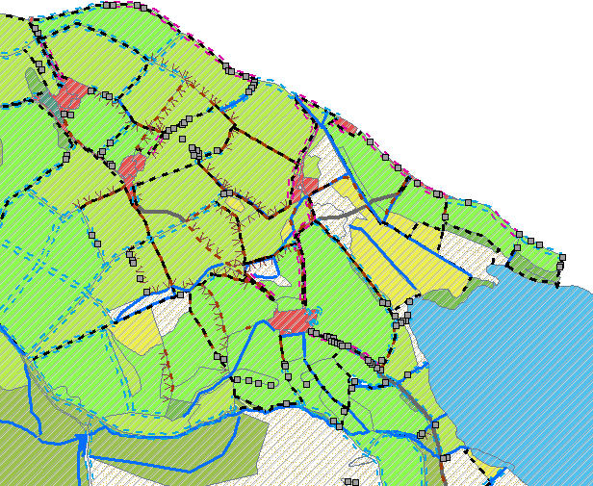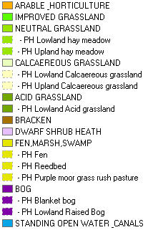T

The key here is incomplete but gives you some idea. As well as the different colours for each habitat, each line type represents a different feature (e.g. hedge, line of trees, wall etc) and each grey square indicates the presence of a ‘point’ feature which may be a tree, a clump of trees, a small building etc. Red areas are ‘urban’, i.e. buildings. For each area, I enter data on habitat type and dominant plant species as well as ‘use’. I have also started to look at some detailed ‘plots’ (measured areas) within the catchment to provide some detailed data on which species are present in the different habitat types in different parts of the catchment. However, this work is best done in Spring/Summer when plants are at their most apparent, so I hope to complete that work next year.

The second thing that has been happening in terms of assessing the land in the catchment has been a survey of the farmers which has been carried out by John Rockliffe, an agricultural consultant at Mitchells with a lot of experience and knowledge of the catchment. John has been visiting each of the farmers to talk with them about how they manage their fields, what sort of livestock they have, where they are housed, what is brought in for feed and fertiliser etc and he has also taken soil samples across the catchment. We are very grateful to the farmers for their co-operation with this part of the project as it provides invaluable insights into the land use in the catchment. I have often joined John on his visits as I have found it very interesting to marry up my maps with the way the land is managed and have learnt a great deal about just how complex farming is, not least of which the variety of different names that stock are known by. Do you know what a ‘stirk’ is? (ask a farmer).

Once the data from the catchment mapping is completely finished (I have a few small areas to cover on the steep part of Darling Fell) I hope to be able to use it, alongside John’s data, to look at potential sources of phosphorus input to the lake (see freshwater section). Whilst this sounds very straightforward, it isn’t something that has yet been done in the way that we are trying to do it. At the moment, there are either some very general models (mathematical equations) which use very basic data from a catchment to predict how much phosphorus is likely to be going into water, or there are detailed experiments which look at movement of phosphorus through soil at a

limited scale. Hence, the use of pretty detailed local scale data will be something of an experiment.

A second use of the data is to look at the ecological value of the catchment, and particularly the farmed land, in relation to its economic value. This work will attempt to quantify the ecological quality of the land in terms of habitat types present, the diversity of habitats as well as plant species diversity. I will probably use the rates paid for different feature/landscape management options under the new Entry Level Scheme (the basic agri-environment scheme which Defra would like all farmers to enter into) to provide a valuation. The farmers have kindly provided some insight into the economic value of the land and the potential economic value of the land which we’ll use (without broaching confidentiality, of course).

Assessing the freshwater ecology of Loweswater

Stephen Maberly and Ian Winfield, Centre for Ecology and Hydrology, are working on this part of the project.

There have been three main activities carried out in the past 18 months to assess the ecological quality on Loweswater. The first has been a routine monthly assessment of the physical, chemical and biological properties of the lake. This is a continuation of other surveys carried out in the past, so allowing any improvements (or deterioration) in the lake condition to be detected. There are some signs of improvement: the minimum oxygen concentration at 10 m has been increasing since the very low concentrations
recorded in 2000 and 2005 and the April concentrations of phytoplankton (judged from the concentration of the green photosynthetic pigment chlorophyll a) are similarly lower. However chlorophyll a concentrations at other times of year are fairly unchanged and the concentration of total phosphorus has only declined slightly.

The second activity has been the establishment of the monitoring buoy on the lake. This followed a detailed discussion with the local community and the National Trust on the merits and demerits of having the buoy on the lake. The buoy was installed in December 2007 and has been collecting data since then but we have been plagued with a number of technical problems that prevented us from displaying the real-time data on the internet. I am pleased to say that these problems have nearly been solved and you should shortly be able to view the data on www.lancaster.ac.uk\fass\projects
\loweswater. An example of the data is shown below.

The third activity has been an assessment of the condition of the fish populations in Loweswater led by Ian Winfield at CEH. So far we have carried out a hydroacoustic and net survey in June 2007 and a further hydroacoustic survey in June 2008. The surveys have revealed that the fish community is dominated by inshore perch in good condition, but there are few fish in the open water. There are also smaller numbers of brown trout, pike and minnows. The work on fish has aroused a lot of local interest and we are pleased to be involving a local (from Cockermouth), Mr Andrew Shaw, who will be assessing anglers’ catch returns and electrofishing survey records held by the National Trust and Environment Agency, respectively, and as many other sources of data as possible as part of his Masters thesis.

Temperature at different depths in Loweswater during 2008.

The graph shows that the surface waters become relatively hot- nearly reaching 20oC while the waters at depth only reach 12 or 13oC at the end of the summer. The time when different temperatures occur at different depths denotes when the lake is 'stratified' into a warm upper layer and a cold lower layer. You can also detect daily to weekly periods of temperature change in the surface waters during summer that is caused by changing weather conditions.

In the future we plan to use the data from the monitoring buoy, plus data from the farm survey and our previous studies on nutrient sources to the lake to produce a detailed model of how Loweswater might respond if different management procedures were implemented. These might include improving all septic tanks in the catchment, reducing fertilizer applications, reducing losses from slurry tanks or changing household detergents to phosphorus free forms. Since almost all these changes involve a cost it is important to be able to assess how much of an ecological benefit they will have so that their overall value can be judged.

- Concluding Remarks

The research carried out so far has yielded many interesting results, some of which are discussed in this report. We shall continue, as we analyse the data, to put new findings on our website (www.lancaster.ac.uk\fass\projects\loweswater) and to discuss these at Loweswater Care Project meetings. Bringing together scientific research and local knowledge and experience we hope to gain a fuller understanding of the nature of the interactions that shape this catchment, and decide, through the LCP, what actions might be taken to achieve a balance between human needs and the natural world in Loweswater.

